African Bush Camps Takes Live COVID-19 Talks Online

Last week, African Bush Camps (ABC) broadcasted its first live online video discussion addressing concerns surrounding the COVID-19 ripple effect on Africa tourism, wildlife conservation, and community support.
After the safari travel operator successfully debuted its Safari Talk ‘show’, featuring South African and Zimbabwean industry leaders, a heightened demand for relevant discussions has called for the live insert to become a regular feature.

Joining African Bush Camps (ABC) founder and professional safari guide, Beks Ndlovu, on Monday 6 April, was Mark Brightman (lead at Bumi Hills Anti-poaching Unit in the Lake Kariba region, Zimbabwe), and Obert Manyeza (head of and trust manager at the ABC Foundation), to discuss the visible impact of COVID-19 regulations on their operations and the way forward.

The 53-minute broadcast went live on Monday at 6 pm (GMT +2) on Facebook and YouTube. The recording can be accessed here: https://www.youtube.com/watch?v=qRCq68lwEDw&t=1046s

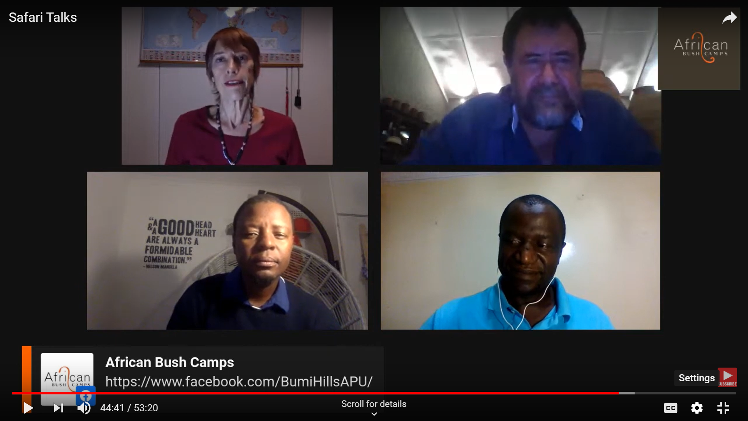
(Clockwise, from top left: Lesley Stones (freelance travel journalist), Mark Brightman (BHAPHU), Obert Manyeza (head of and trust manager at ABCF) and Beks Ndlovu (ABC founder and safari guide)

While talks about behind-the-scenes processes were high on the agenda, facilitator and freelance travel journalist, Lesley Stones, navigated the topics to ensure viewers’ concerns were addressed across the board. “National and international news sources are doing a good job covering all COVID-19 related aspects,” says Stones. “This was an opportunity to take a deeper look into the spectrum of the virus’ influence on sustainable tourism, particularly in southern Africa.”
“Numerous encouraging messages about the benefits of travelling to Africa after lockdown have been shared across the world”, says Ndlovu. “Additionally, we wanted to give people something tangible to refer to - a real-time account of what is happening in our and our partners’ corners. A live, uncensored discussion on accessible online platforms where viewers could actively participate seemed ideal.”
Leading straight into one of the most topical issues at current, the impact of the virus’ spread on on-the-ground procedures in hospitality, Ndlovu shared that ABCs camp and lodges (15 across Zambia, Zimbabwe, and Botswana) remain open to continue the facilities’ upkeep. “As a number of the camps are located in remote areas, it’s unavoidable to leave the properties unattended,” says Ndlovu. “We also want to keep our staff motivated, oversee the surrounding environment and help protect the wildlife roaming our properties. We have also have responsibility to preserve our resources and continue giving back to our communities.”
ABC currently employs over 600 people in four countries including South Africa. As many hospitality operators are experiencing, ABC is facing the financial challenges construed by the ban on international travel. The company has decided to keep all personnel employed during a ‘curl up’ period. Properties are now in a ‘hibernation stage’ until all ports of entry are open again. ABC had to reduce its staff’s time with at least 25 percent and put a rotation schedule in place to ensure all employees can report for work during this period.
Wildlife conservation and human-wildlife conflict in vulnerable areas were priority focuses during the live talk. These elements’ association with lost jobs, paused or lower levels of income, limited support from income-generating companies put conservation at the forefront of concerns and expectations for increased poaching patterns are rife.
“At this point, BHAPHU (Bumi Hills Anti-poaching Unit) is unaffected and continues to operate 24/7 with the help of national parks and the army,” adds Brightman. “However, since the start of the lockdown, there has been a definite rise in the number of snares we have tracked. This is understandable considering the economic situation. While we can only hope the lockdown does not continue for long, we need to rise to the challenge to keep our wildlife safe.”

Since 2006, the Bumi Hills region lost 75 percent (approximately 15 000) of its elephant population due to poaching. Today, BHAPU and its partners have managed to start to reverse this. “Feeding information to communities and making people understand the benefit of conservation for tourism, and in turn, their livelihoods, have certainly been a big help,” says Brightman. “With lower income levels now, it’s expected that things will take a different turn, and there is an increased risk of elephant poaching.”
For the ABC Foundation (ABCF), its main purpose is to encourage partnerships among the communities they support and urge local people’s cooperation to help offset any harm to wild animals. ABCFs key areas of focus - education, conservation, and community empowerment - have been the driving forces behind its mission. In terms of education, the Foundation pioneered a feeding scheme to entice kids to attend classes and remain in school. For most, it may have been their only meal of the day. Now, due to government regulations to help curb the spread of COVID-19, school gatherings have been put to a stop.
According to Manyeza, the halt on tourism has certainly affected the Foundation’s initiatives. “Luckily, with the additional help of external donors and agent partners, we can continue with the most pressing projects and put longer-term measurements in place. Among others, this includes installing boreholes in villages. This helps us to show the local people our continued support even though we are running on a limited spend.”
On being asked about the gauged longevity of the current situation and solutions to long term effects in tourism, Ndlovu stated that ABC is preparing for a ‘hunkering down’ period of four months before retaking operations. “For now, we are encouraging travellers to book ahead of time,” says Ndlovu. “Tourism needs it. For the basic survival of the industry and its various counterparts, the reassurance that people will retake their trips later is a shining beacon of hope.” To accommodate postponements and rescheduled travel plans, ABC has relaxed its booking Ts and Cs, giving travelers peace of mind they can shift their bookings out as far as March 2021 at no extra expense. The company is also offering intriguing discounts for post lockdown travel.
The live discussion was well-received online as information seekers’ questions reached the participants. Due to the first Safari Talk’s high attendance, the necessity of continued discussions in the Safari sector, naturally considering the impact of COVID-19, has been earmarked. More regular features are being planned with the next episode due to air next week (week of 13 April 2020).

For more information on the ABC Foundation and ways to support, visit https://www.africanbushcampsfoundation.org/

Visit the BHAPU Facebook page for details here: https://www.facebook.com/BumiHillsAPU/

For the latest updates, follow ABC on Instagram, Facebook, LinkedIn and Twitter.

Visit: www.africanbushcamps.com

About African Bush Camps
African Bush Camps (ABC) is a 100% owner-run, African-based safari company designed to delight adventure travelers with authentic safari experiences amid untamed wilderness across Botswana, Zimbabwe, and Zambia. Operations are always focused on the guests, with 15 luxury tented bush camps and lodges, offering seamless safari experiences with internal flights, food, drinks, and activities included. African Bush Camps promotes and influences travel to Africa on a global scale while operating with a strong focus on conservation, and an environmentally sustainable footprint that celebrates the culture of communities in the areas in which it operates.

The African Bush Camps Foundation is a nonprofit organisation focused on conservation, education, and empowerment for the communities that surround the company’s camp locations. Launched in 2006, the Foundation operates through a multi-faceted partnership with the company, which donates USD10 to the Foundation for every bed night accommodated in each of its camps. All donations go directly to community-based development projects initiated by the Foundation. Since opening, the Foundation has spearheaded 72 community projects across Botswana, Zimbabwe, and Zambia; 42 of those projects are currently in operation under the Foundation’s wing.

African Bush Camps was founded in 2006 by Beks Ndlovu, a professional safari guide born and raised in the village of Luparie on the outskirts of Hwange National Park in Zimbabwe. From the start of operations, Ndlovu’s mission has been to operate a portfolio of luxury tented camps and lodges across Botswana, Zimbabwe, and Zambia that reincarnate the fantasy of ‘Old Untouched Africa,’ while treating guests to authentic and adventurous professional guide-led experiences and bespoke safaris that can only be found in the bush.

